**ASSIGNMENT-9**

Ques 1: Create a container for the below bash script(**prime.sh**).

1. Create a Dockerfile
2. Create a Docker Image

Find the script here <https://github.com/DARK-art108/Bash-Scripts>

**Step-1: Create a DockerFile**

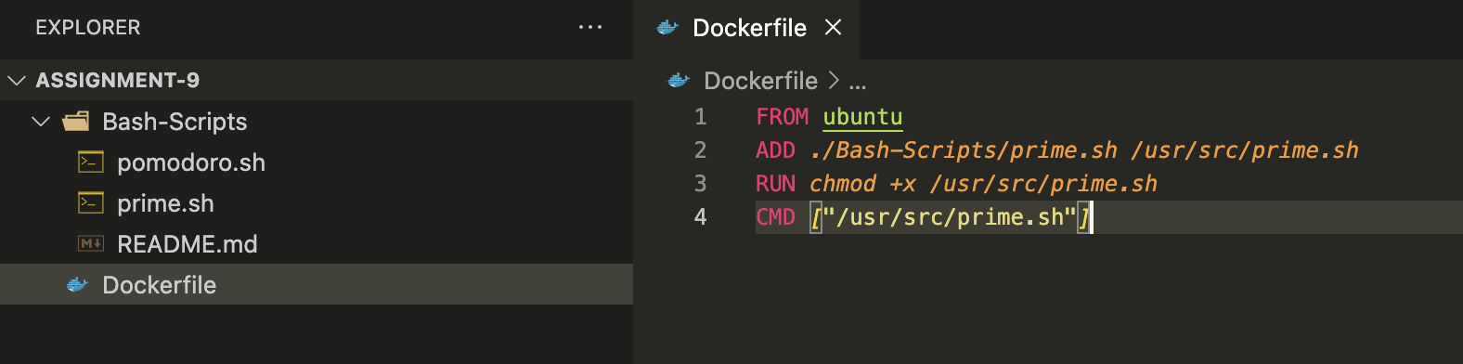

**Step-2: Build a Docker Image**

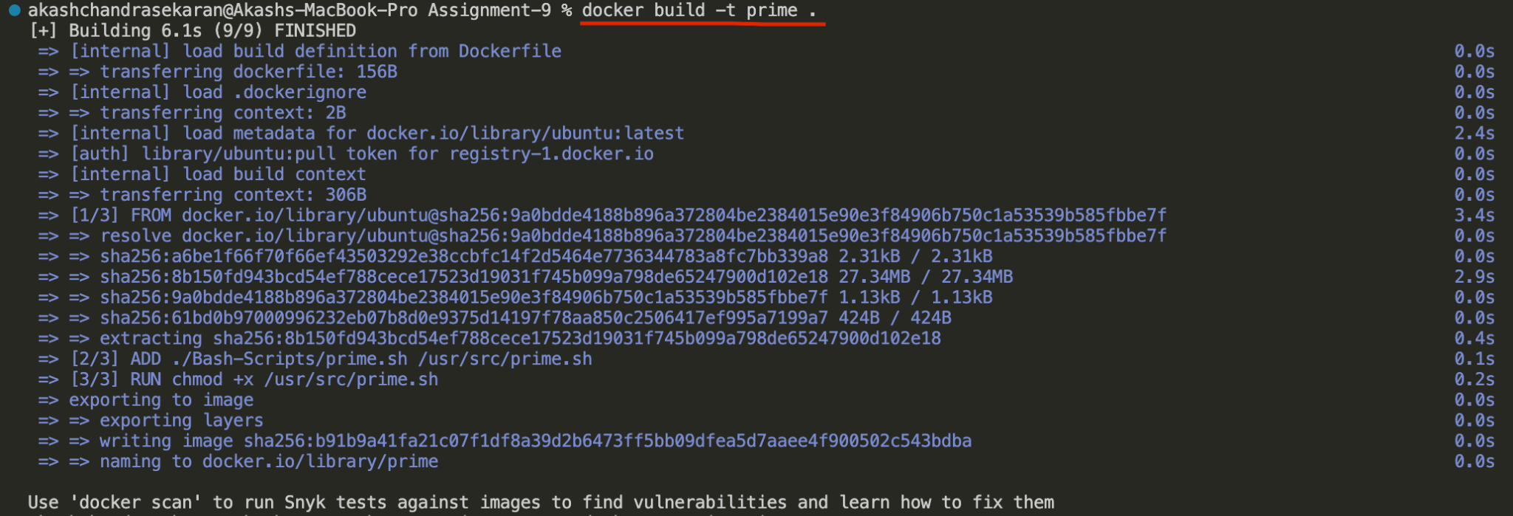

**Step-3: Run the Docker Image**

**Result:**



**Image:**



**Container:**

